שאלה 1:

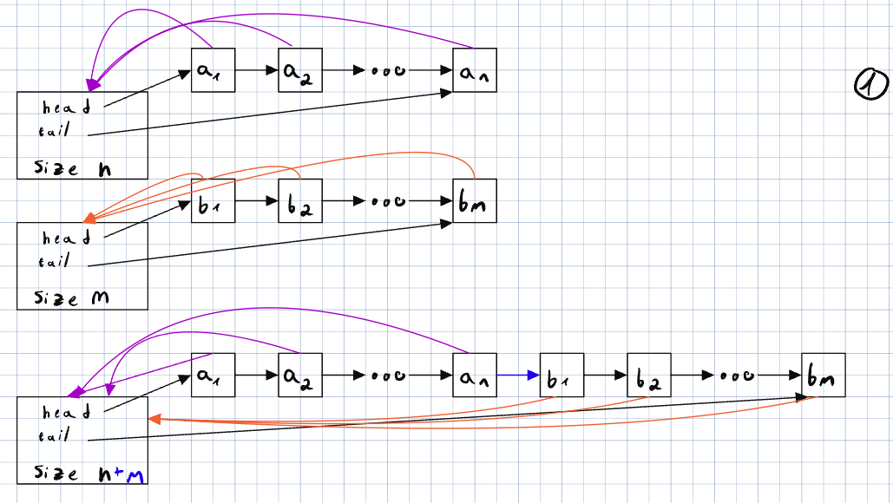

We will loop over all the items in the smaller list, and just change the pointer for the head and the tail.

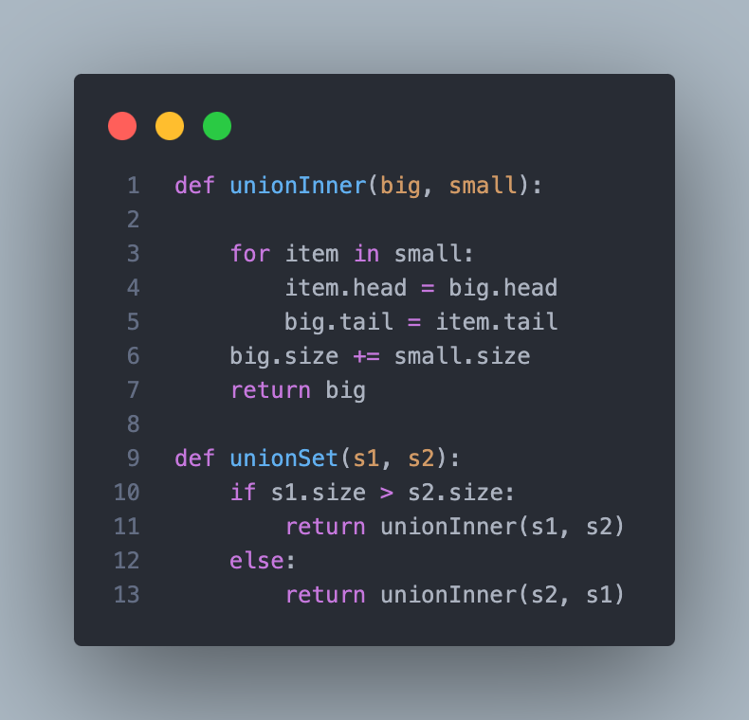

ב:

In every step we increase the size by maximum of 2.

אוסף של כל האברים היחידים, בעצם n פעולות make.

Join M elements with K elements where M > K will take

We prove this is section one.

If we join each group as follow, we choose the two smallest groups and join them.

We will get total of actions.

Where each action we be at most

So we get

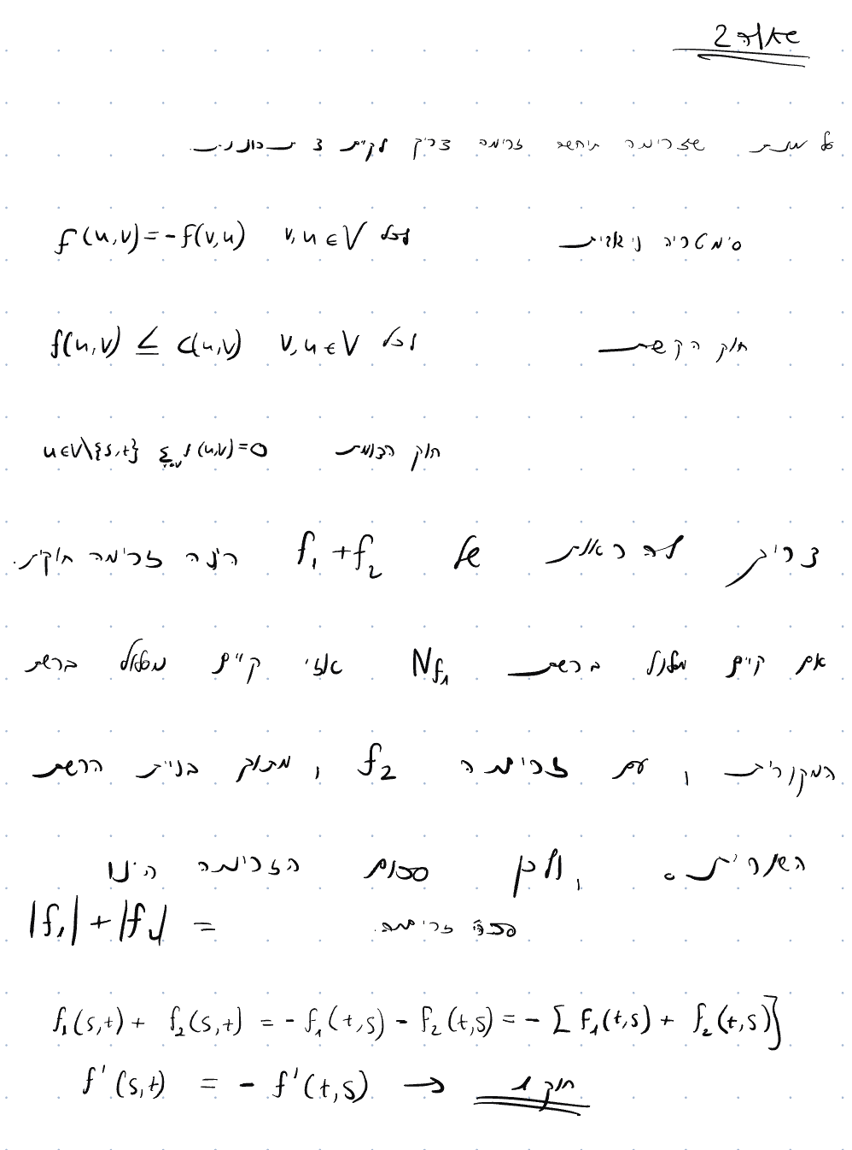

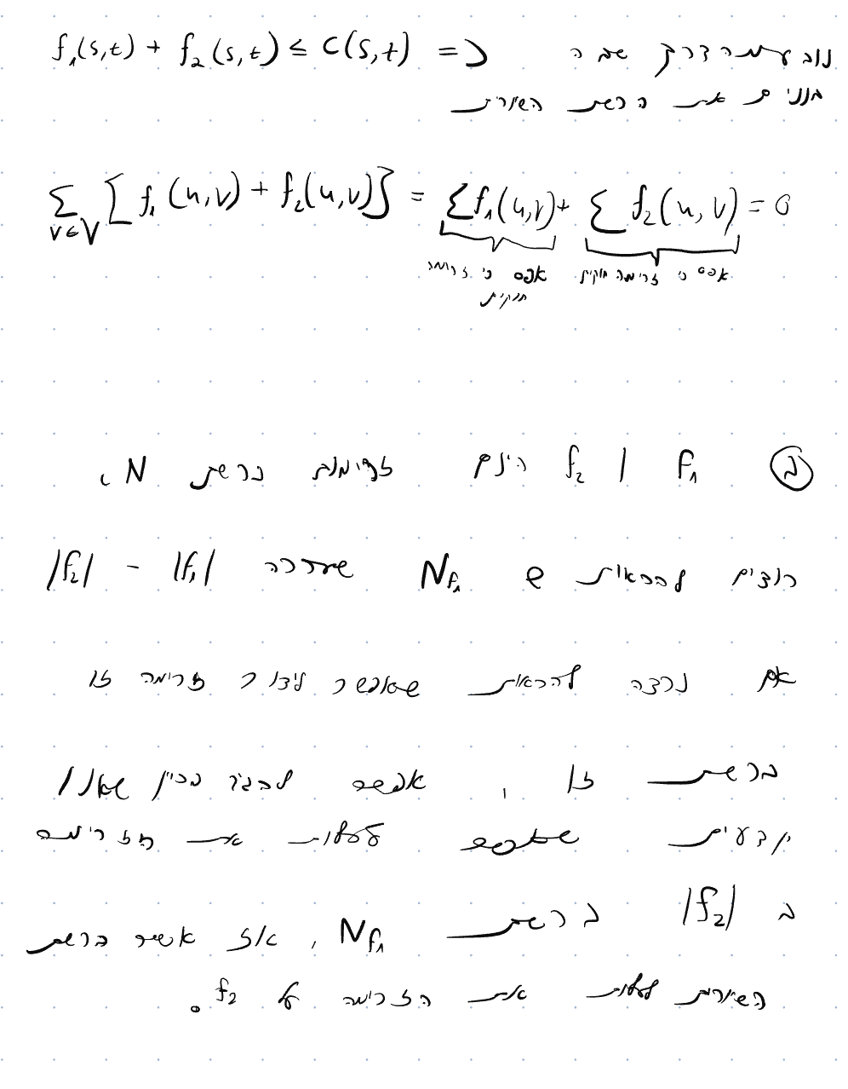

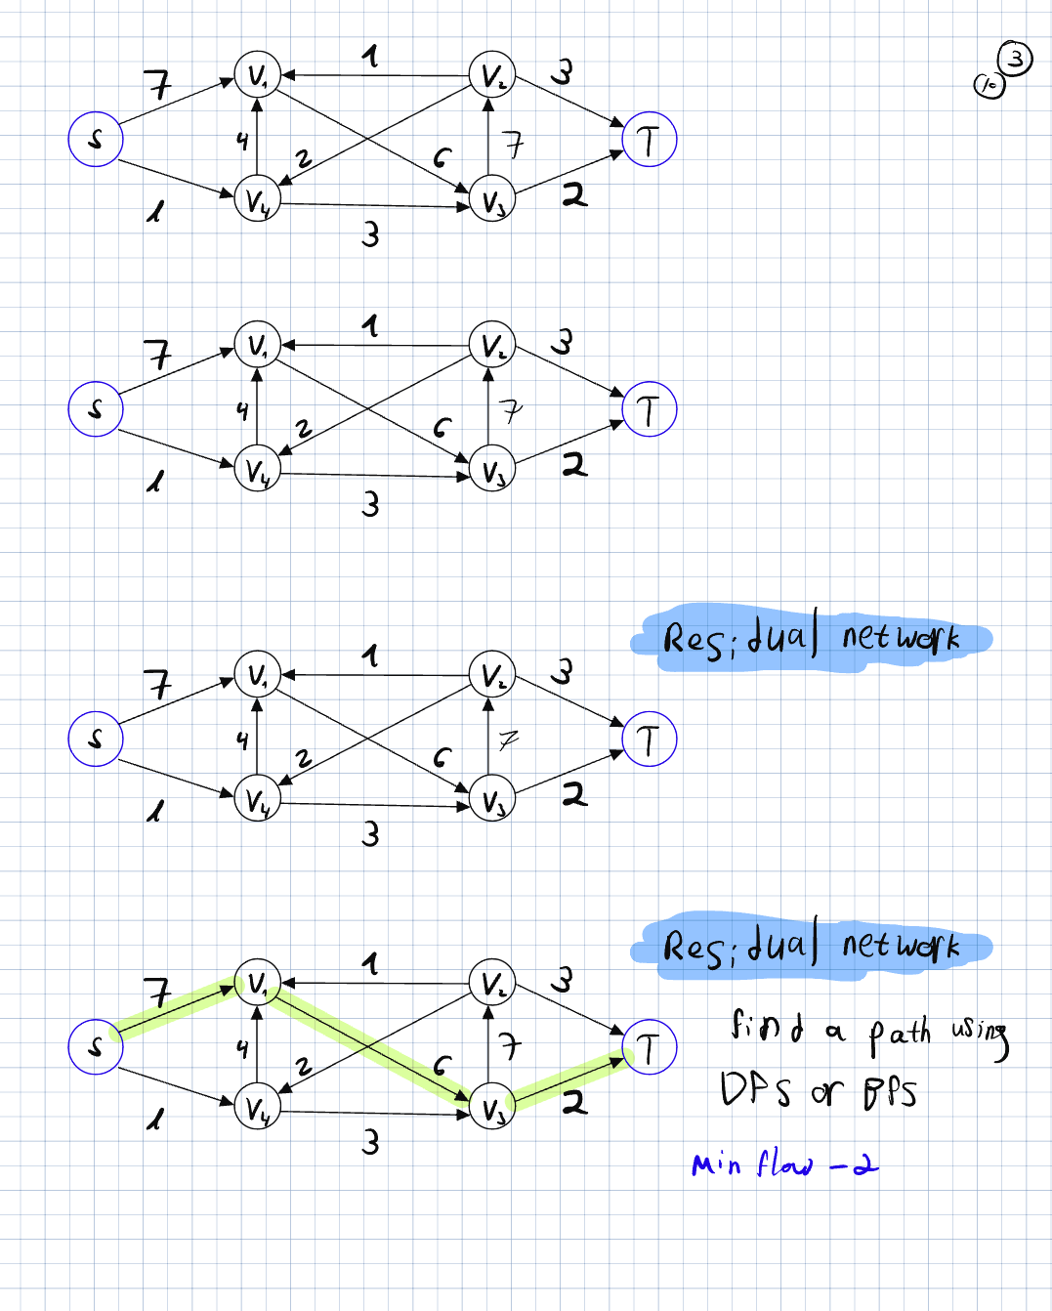

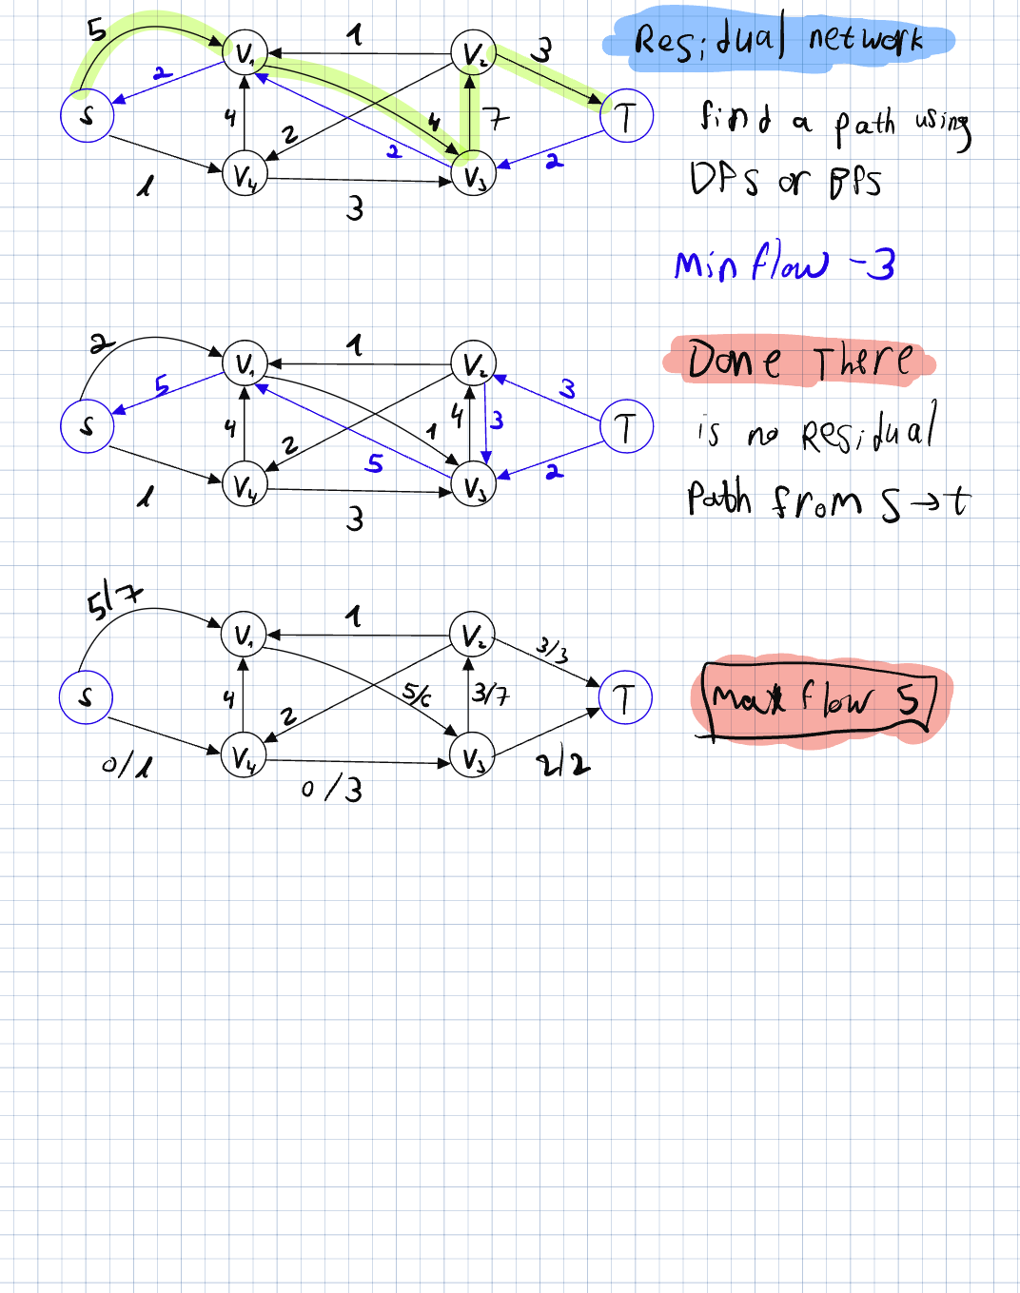

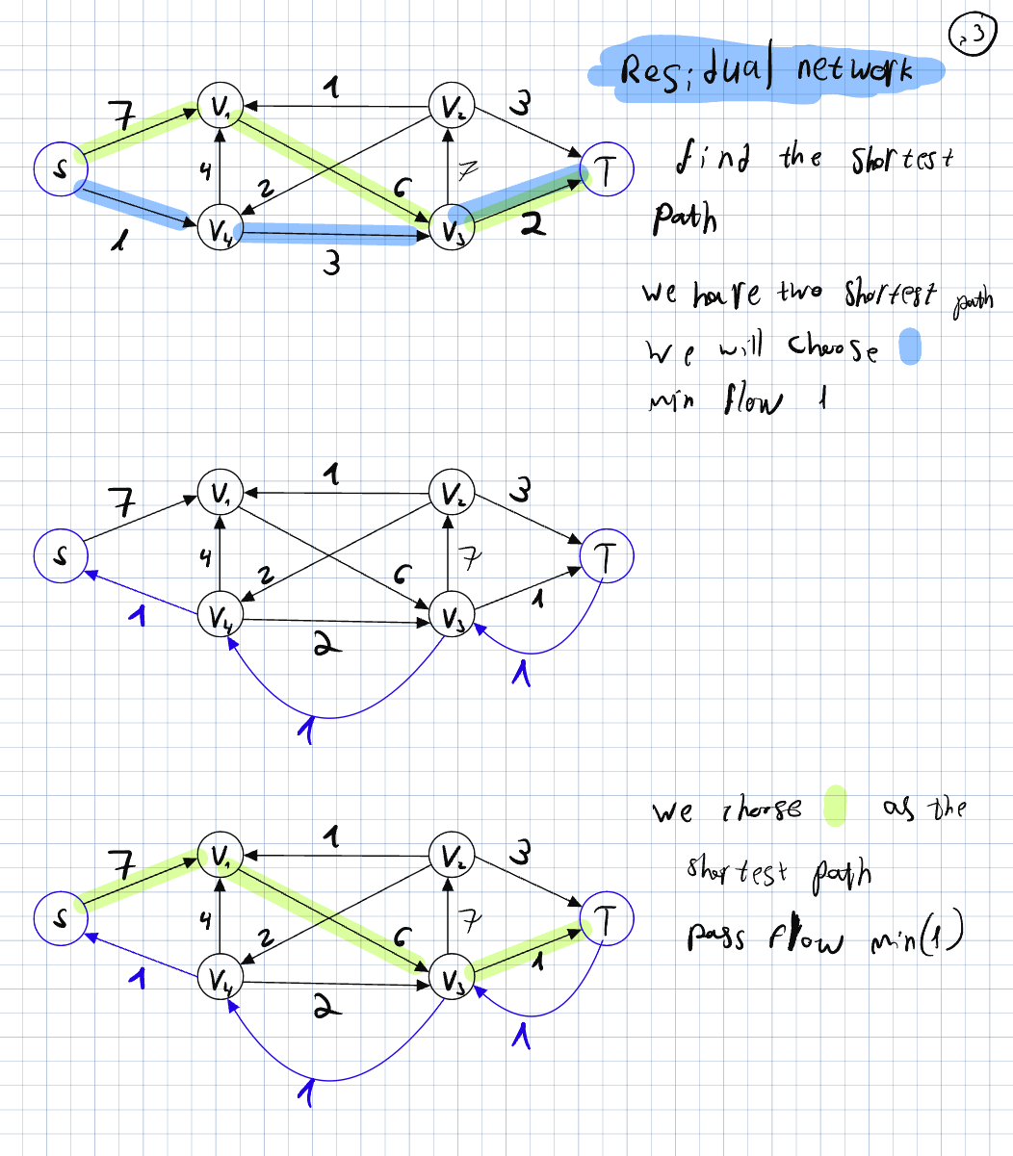

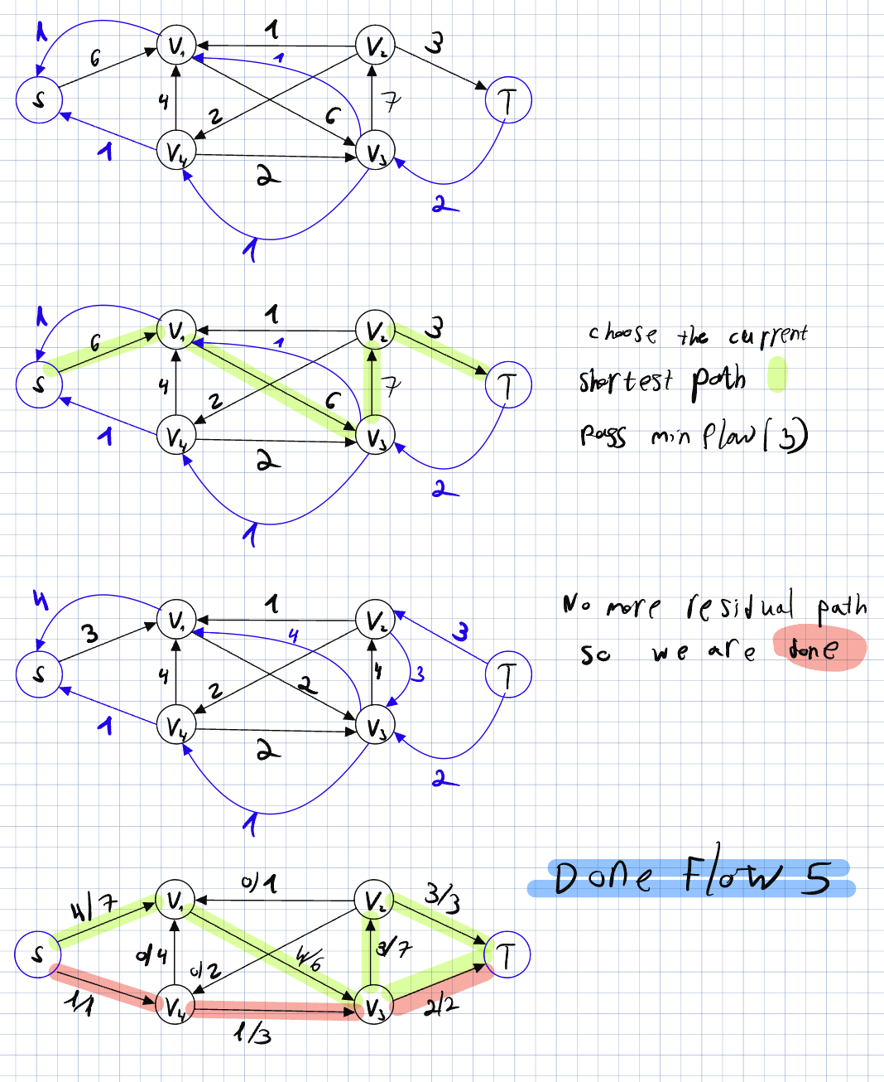

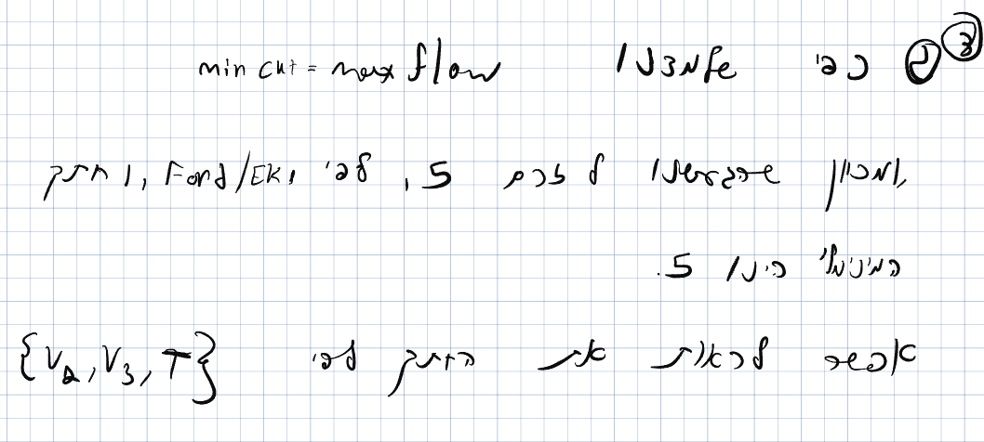

שאלה 4

1. Create the residual graph O(V+E)
2. Find a path from the source to the target in the residual graph. If you find return False. O(V + E)
3. Else return true. O(1)

Step 1:

Creating the residual graph, we will need to copy the graph and creating the residual while copy.

Just to note if we don’t copy the graph but modify the existing one this will take O(E) time.

Step 2:

Finding if there is a path using BFS or DFS will take O(V+E)

Total running time is O(V+E)